CHANGES HISTORY
PIC | Date | Remarks
BJM.MR | 2018.06.22 | Created
Ghaida | 2018.04.17

TOC
- Market Company
- Market Company Office
- Market Company Contact
- Market Company MI
- Market Company External Identification
- Market Company Counterpart
- Market Company Bank
- Market Company Deposit
- Market Company Custodian
- Market Company Deposit Days
- Market Company Office Days
Diagram ENTITY RELATIONSHIP
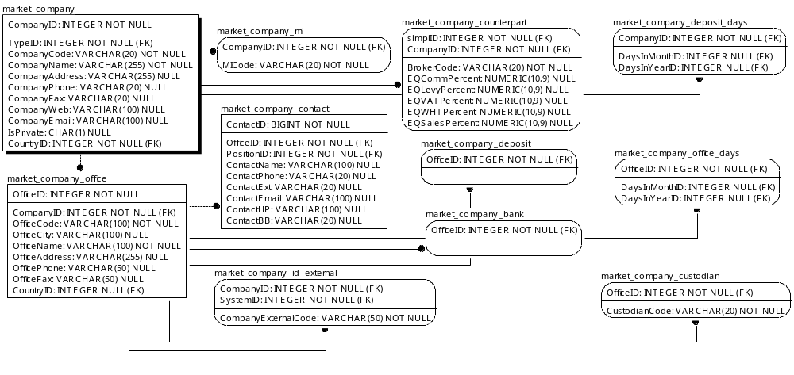

TABLE RELATIONSHIP
No | Table 1 | Table 2 | Type (1:1; 1:N; M:N) | Description
1. | market_company | market_company_mi | 1:1
2. | market_company | market_company_counterpart | M:N
3. | market_company | market_company_deposit_days | 1:1
4. | market_company | market_company_office | 1:1
5. | market_company | market_company_id_external | M:N
6. | market-company_office | market_company_contact | M:N
7. | market-company_office | market-company_office_days | 1:1
8. | market-company_office | market-company_bank | 1:1
9. | market-company_office | market-company_deposito | 1:1
10. | market-company_office | market-company_custodian | M:N

Name |  | market_company
Objective |  | Menyimpan data master company seperti emiten saham/obligasi/reksa dana, bank, securities brokerarge, …
No | Column |  | Type | Rule  (PK, FK, Key, NN, Unik, Index) | Description
1 | CompanyID |  | Integer | PK | Nomor id dari setiap company
2 | TypeID |  | Integer | FK
3 | CountryID |  | Integer | FK
4 | CompanyCode |  | Varchar(20) | Key, NN, Unik, | Code atau singkatan yang dibuat untuk masing-masing company dari inisial nama company atau yang lainnya.
5 | CompanyName |  | Varchar(255) | NN | Nama dari company
6 | CompanyAddress |  | Varchar(255) | Null | Alamat dari company pusat
7 | CompanyPhone |  | Varchar(20) | Null | Nomor telepon dari company pusat
8 | CompanyFax |  | Varchar(20) | Null | Nomor Fax dari company pusat
9 | CompanyWeb |  | Varchar(100) | Null | Alamat web dari company
10 | CompanyEmail |  | Varchar(100) | Null | Alamat email company pusat
11 | IsPrivate |  | Char(1) | FK, NN

SAMPLE DATA
No | Column | Sample 1 | Sample 2 | Sample 3 | Sample 4
1 | CompanyID | 1 | 2 | 3 | 4
2 | TypeID | 1 | 1 | 1 | 1
3 | CountryID | SIMPI-PRO | ABBA | ABDA | ABMM
4 | CompanyCode | PT SIMPI PROFESSIONAL INDONESIA | Mahaka Media Tbk. | Asuransi Bina Dana Arta Tbk. | ABM Investama Tbk.
5 | CompanyName
6 | CompanyAddress
7 | CompanyPhone
8 | CompanyFax
9 | CompanyWeb
10 | CompanyEmail | Y | N | N | N
11 | IsPrivate | 1 | 1 | 1 | 1

Name |  | market_company_office
Objective |  | Menyimpan data kantor dari satu market company, misalnya kantor cabang bank
No | Column |  | Type | Rule  (PK, FK, Key, NN, Unik, Index) | Description
1. | OfficeID |  | Integer | PK | Nomor ID dari cabang kantor
2. | CompanyID |  | Integer | FK,NN | ID company yang sama dengan ID pusat
3. | OfficeCode |  | Varchar(100) | Unik, NN
4. | OfficeCity |  | Varchar(100) | Null
5. | OfficeName |  | Varchar(100) | NN
6. | OfficeAdress |  | Varchar(255) | Null
7. | OfficePhone |  | Varchar(50) | Null
8. | OfficeFax |  | Varchar(50) | Null
9. | CountryId |  | Integer | FK, Null

SAMPLE DATA
No | Column | Sample 1 | Sample 2 | Sample 3 | Sample 4
1. | OfficeID | 1 | 52 | 57 | 58
2. | CompanyID | 1 | 812 | 817 | 818
3. | OfficeCode | SIMPI-PRO | AVRAM | Fund Manager | IFA
4. | OfficeCity | SIMPI-PRO | AVRAM | Fund Manager | IFA
5. | OfficeName | SIMPI-PRO | AVRAM | Alamat Jalan
6. | OfficeAdress | SIMPI-PRO | AVRAM | telpon
7. | OfficePhone | SIMPI-PRO | AVRAM
8. | OfficeFax | JAKARTA | JAKARTA | JAKARTA | JAKARTA
9. | CountryId | 1 | 1 | 1 | 1

Name |  | market_company_contact
Objective |  | Menyimpan data dari PIC masing-masing kantor cabang.
No | Column |  | Type | Rule  (PK, FK, Key, NN, Unik, Index) | Description
1 | ContactID |  | BIGInteger | PK
2 | OfficeID |  | Integer | FK
3 | PositionID |  | Integer | FK
4 | ContactName |  | Varchar(100) | Null
5 | ContactPhone |  | Varchar(20) | Null
6 | ContactExt |  | Varchar(20) | Null
7 | ContactEmail |  | Varchar(100) | Null
8 | ContactHP |  | Varchar(100) | Null
9 | ContactBB |  | Varchar(20) | Null

SAMPLE DATA
No | Column | Sample 1 | Sample 2 | Sample 3 | Sample 4
1. | ContactID
2. | OfficeID
3. | PositionID
4. | ContactName
5. | ContactPhone
6. | ContactExt
7. | ContactEmail
8. | ContactHP
9. | ContactBB

Name |  | market_company_mi
Objective
No | Column |  | Type | Rule  (PK, FK, Key, NN, Unik, Index) | Description
1 | CompanyID |  | Integer | FK
2 | MICode |  | Varchar(20) | NN

SAMPLE DATA
No | Column | Sample 1 | Sample 2 | Sample 3 | Sample 4
1. | CompanyID | 1 | 812 | 817 | 818
2. | MICode | SIMPI-PRO | AVRAM | Fund Manager | IFA

Name |  | market_company_id_external
Objective
No | Column |  | Type | Rule  (PK, FK, Key, NN, Unik, Index) | Description
1 | CompanyID |  | Integer | FK
2 | SystemID |  | Integer | FK
3 | CompanyExternalCode |  | Varchar(50) | NN

SAMPLE DATA
No | Column | Sample 1 | Sample 2 | Sample 3 | Sample 4
1. | CompanyID | 12 | 60 | 61 | 84
2. | SystemID | 4 | 4 | 4 | 4
3. | CompanyExternalCode | BRI AGRO | BCA | BANK BUKOPIN | Bank Jabar Banten

Name |  | market_company_counterpart
Objective
No | Column |  | Type | Rule  (PK, FK, Key, NN, Unik, Index) | Description
1. | SimpiID |  | Integer | FK
2. | CompanyID |  | Integer | FK
3. | BrokerCode |  | Varchar(20) | NN
4. | EQCommPercent |  | Numeric(10.9) | Null
5. | EQLevyPercent |  | Numeric(10.9) | Null
6. | EQVATPercent |  | Numeric(10.9) | Null
7. | EQWHTPercent |  | Numeric(10.9) | Null
8. | EQSalesPercent |  | Numeric(10.9) | Null

SAMPLE DATA
No | Column | Sample 1 | Sample 2 | Sample 3 | Sample 4
1. | SimpiID | 1 | 358 | 722 | 723
2. | CompanyID | SIMPI-PRO | GR | DX | CC
3. | BrokerCode | 0 | 0 | 0 | 0
4. | EQCommPercent | 0 | 0 | 0 | 0
5. | EQLevyPercent | 0 | 0 | 0 | 0
6. | EQVATPercent | 0 | 0 | 0 | 0
7. | EQWHTPercent | 0 | 0 | 0 | 0
8. | EQSalesPercent | 1 | 358 | 722 | 723

Name |  | market_company_bank
Objective
No | Column |  | Type | Rule  (PK, FK, Key, NN, Unik, Index) | Description
1 | OfficeID |  | Integer | FK

SAMPLE DATA
No | Column | Sample 1 | Sample 2 | Sample 3 | Sample 4
1. | OfficeID | 1 | 52 | 57 | 58

Name |  | market_company_deposit
Objective
No | Column |  | Type | Rule  (PK, FK, Key, NN, Unik, Index) | Description
1 | OfficeID |  | Integer | FK

SAMPLE DATA
No | Column | Sample 1 | Sample 2 | Sample 3 | Sample 4
1. | OfficeID | 1 | 52 | 57 | 58

Name |  | market_company_custodian
Objective
No | Column |  | Type | Rule  (PK, FK, Key, NN, Unik, Index) | Description
1 | OfficeID |  | Integer | FK
2 | CustodianCode |  | Varchar(20) | NN

SAMPLE DATA
No | Column | Sample 1 | Sample 2 | Sample 3 | Sample 4
1. | OfficeID | SIMPI-PRO | AVRAM | Fund Manager | IFA
2. | CustodianCode | 1 | 52 | 57 | 58

Name |  | market_company_deposit_days
Objective
No | Column |  | Type | Rule  (PK, FK, Key, NN, Unik, Index) | Description
1 | OfficeID |  | Integer | FK
2 | DaysInMonthID |  | Integer | FK
3 | DaysInyearID |  | Integer | FK

SAMPLE DATA
No | Column | Sample 1 | Sample 2 | Sample 3 | Sample 4
1. | CompanyID | 60 | 64 | 66 | 68
2. | DaysInMonthID | 2 | 2 | 2 | 2
3. | DaysInyearID | 2 | 2 | 2 | 2

Name |  | market_company_office_days
Objective
No | Column |  | Type | Rule  (PK, FK, Key, NN, Unik, Index) | Description
1 | CompanyID |  | Integer | FK
2 | DaysInMonthID |  | Integer | FK
3 | DaysInyearID |  | Integer | FK

SAMPLE DATA
No | Column | Sample 1 | Sample 2 | Sample 3 | Sample 4
1. | CompanyID | 60 | 64 | 66 | 68
2. | DaysInMonthID | 2 | 2 | 2 | 2
3. | DaysInyearID | 2 | 2 | 2 | 2

